Vision 2020
Strategic plan – 2019-2021
Haemophilia NI Committee
Approved December 2019

Contents
Introduction 1
Mission and Values 1
Building Community 2
Advocacy 5
Education 7
Year Plan 2020 10
Haemophilia NI Committee 11
Contact Us 11

Introduction
Haemophilia NI seeks to support patients and families in NI affected by bleeding disorders. It is a patient led group and is committed to being an open and transparent organisation. All are work is underpinned by the principles of good governance as set out in our governing documents and we are accountable to our membership. It is hoped that this document will help explain who Haemophilia NI is, including our ethos and aims for the next 3 years. We aim to officially complete registration as a charity with the NI charities commission within the next 12 months which will be a massive boost. Our work is underpinned by the amazing fundraising efforts of our members without which none of this would be possible and to whom we are greatly indebted. Thank you for taking the time to read about our work and vision for Haemophilia NI in 2020.

Mission and Values

Mission statement
“Haemophilia NI exists to support patients and families affected by bleeding disorders through education and provision of information, fostering of community through programmes and events and advocacy to government, the department of health, healthcare professionals and other key stakeholders. This is all underpinned by principles of good governance.”
Values
“Our primary motivation at all times is the wellbeing of people in Northern Ireland who are affected by bleeding disorders. We seek to be a truly inclusive cross-community group which acts with transparency, honesty and accountability to members. Our work aims to empower the bleeding disorders community in Northern Ireland and make the lives of people affected by bleeding disorders easier where possible. “

Building Community
Children and families
  - Haemophilia NI seeks to support children and families affected by bleeding disorders through a variety of educational events. This year we aim to include child and family specific workshops at our family day at the Ulster American Folk Park in spring and a further workshop for parents and children at Jack Straw’s Board Games café in September. We also run an annual trip to see Santa, last year this was run through Belfast Activities centre and in 2019 will be run through Titanic Belfast. We plan to have this as an annual event on an ongoing basis.
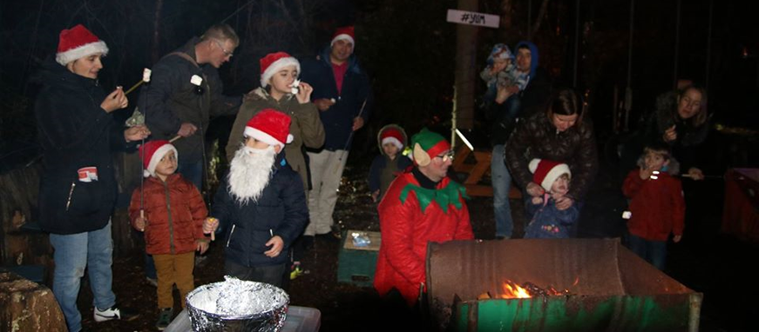
Members meeting the Elves at Belfast Activity Centre in December 2018

Youth

  - Haemophilia NI has developed a new youth education booklet in Partnership with SOBI (Swedish Orphan Biovitrium – a pharmaceutical company). This is due to be launch in January 2020 at a high-octane go-karting event for boys with haemophilia. We also intend to run a youth workshop as part of our all members day at the Ulster American Folk Park in spring. Long term we aspire to organise residential youth weekends but this would realistically be for 2021 and beyond.

The Haemophilia NI Youth Booklet developed in association with SOBI

Women

  - Haemophilia NI recognises that women are also profoundly affected by bleeding disorders and rejects the old stereotype of bleeding disorders as ‘male-only diseases’. Haemophilia NI wants to raise awareness that women are also affected by bleeding disorders and that this can have significant problems around issues such as menstruation and pregnancy. Haemophilia also recognises that even women without bleeding disorders are often significantly affected when partners or other family members have bleeding disorders. Haemophilia NI is pleased to be hosting a women’s event for all women affected by bleeding disorders at any level in March time. We plan to offer ongoing support to women affected by bleeding disorders over the next three years.

Working with other patient groups

  - The bleeding disorder community is global and Haemophilia NI actively wants to promote strong and positive links with other patient groups, in particular other societies within the UK and Ireland including; the UK Haemophilia Society, The Irish Haemophilia Society, Haemophilia Scotland and Haemophilia Wales. Haemophilia NI hopes to be able to partner with Haemophilia Scotland in governance training within the next year and arrange meetings with the Irish Haemophilia Society. Haemophilia NI has already been collaborating very actively with Haemophilia Wales and Haemophilia Scotland as part of the Infected Blood Inquiry and this partnership has certainly served to strengthen the patient voice.

Keeping Members Informed

  - Haemophilia NI seeks to keep in touch with its memberships in numerous ways in order to foster community amongst those affected by bleeding disorders. This includes via:
    - Face-to-face meetings
    - Facebook
    - Twitter
    - Newsletters
    - Website (coming 2020)

Advocacy
Contaminated Blood

  - Haemophilia NI as played a strong role in advocating for and supporting local victims of contaminated blood in Northern Ireland over the past 12 months which have often been very difficult for all infected and affected. Haemophilia NI wants to see an inquiry that provides justice to victims by identifying and holding to account those responsible for the biggest treatment disaster in the history of the NHS. Haemophilia NI has been a registered core participant at the Infected Blood inquiry and has been able to make free legal representation available to local people through Watkins and Gunn solicitors. In particular Haemophilia NI has been working hard to highlight the disparity in payments made to affected people across the UK which has seen Northern Irish victims left less well off than those in other UK regions.

  - Haemophilia NI has also made representations at the Department of Health and with the Business Services Organisation. Haemophilia NI campaigned to ensure access to old medical records would be free for victims requesting access to these.

Access to treatment

  - The world of haemophilia therapeutics is fast changing with multiple new treatments becoming available in recent years such as long-acting replacement therapies. Haemophilia NI seeks to advocate for patients to be able to access new therapies wherever their healthcare professional feels it would benefit their care. Haemophilia NI has made a submission document to the APPG at Westminster looking into treatment access and will be involved as a report is compiled and recommended at the start of the next parliament. Haemophilia NI is keen to promote patient involvement in national tender processes and the raising of target trough levels for factor replacement therapy. We also support having a permanent clinical psychologist attached to the Haemophilia Centre in Belfast.

Haemophilia NI submission to the All Party Group on Access to Treatment

Pharmacy

  - Haemophilia NI already enjoys good links with a number of pharmaceutical companies. We are keen to ensure that pharmaceutical companies develop therapies with patients at the centre of the process. We are also keen to see that pharmaceutical companies give back to the haemophilia community through support of educational patient events. We have worked with SOBI on several projects such as the Haemophilia NI Family Education Day and we seek to continue to partner with SOBI and others in 2020.

Stormont and Westminster

  - Haemophilia NI has been represented in several meetings in Whitehall throughout the course of the contaminated blood inquiry. Meetings taken place with several NI members of parliament regarding the contaminated blood inquiry to ensure NI has a strong local voice. Haemophilia NI hopes to be able to work with the local executive when it is restored so that Haemophilia and other bleeding disorders in NI get priority.

Raising awareness of bleeding disorders in the public discourse

  - Haemophilia NI is working through social media to promote itself and bleeding disorders. This includes through the mediums of Facebook and Twitter. Haemophilia NI hopes to complete its website during 2020 which will offer valuable new opportunities to promote our presence online.

Working with the Haemophilia Centre and healthcare professionals

  - Haemophilia NI enjoys a good working relationship with the Haemophilia Centres at the Belfast City Hospital and Royal Victoria Hospital for Sick Children. We aim to work with healthcare providers to support patients and promote Haemophilia NI events. We also aim to be able to give patient feedback to healthcare providers to help them to continue to improve the services and care which they provide. This included sending representatives to the Belfast Haemophilia centre during their recent external audit in autumn 2019. We plan to hold annual meetings between the Haemophilia Centre in Belfast and Haemophilia NI representatives to ensure a forum for patients voices to be heard by healthcare professionals.

Education

Education relevant to patients and families throughout the life course

  - Haemophilia NI aims to promote education for patients throughout the life course for all those affected by bleeding disorders. For example Haemophilia NI aims to release a new youth education booklet in the New Year covering relevant topics for teenagers such as; dealing with bleeds, exercise and disclosure to friends.

Self-infusion

  - Self-infusion still forms the mainstay of treatment for those affected by severe haemophilia. Haemophilia NI recognises that learning this skill can present a great challenge to both patients and parents. Haemophilia NI seeks to run regular workshops dealing with this tricky issue and create a space for teenagers/children and their parents to get together and support one another.
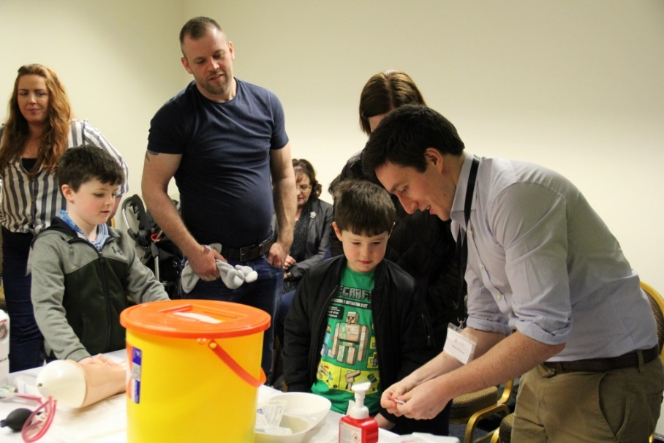
Self-Infusion Training at Haemophilia NI Family day March 2019

Educational events led by medical professionals

  - Haemophilia NI seeks to provide patient education on an evidence based and expert led basis. This includes have medical professionals coming to speak at our meetings from the NI Haemophilia and Thrombosis Centre with whom we enjoy a close relationship as an organisation.
- Building Community
- Children and families
- Youth
- Men
- Women
- Other patient organisations
- Fighting for justice for victims of contaminated blood
- Advocating to ensure patients get access to new therapies
- Working with healthcare professionals to ensure patients receive quality care
- Advocating to the All Party Group on Access to Treatment
- Advocating for patients at Stormont and Westminster
- Raising awareness of bleeding disorders
- Education for patients and families throughout the life course
- Workshops on Self-infusion
- Updates on current and future therapies
- Parenting
- Educational events led by medical professionals

Year Plan 2020

Date | Event | Venue
8th December 2019 | Family Christmas Trail | Titanic Belfast – Belfast
18th January 2020 | Youth Booklet Launch Event | Need4Speed Karting - Ballyclare
14th March 2020 | Women’s Event | Skainos Building - Belfast
May 2020 | All Members Day | Ulster American Folk Park – Omagh
June 2020 | Annual General Meeting | TBC
September 2020 | Family Meeting | Jack Straw Board Games Café – East Belfast
December 2020 | Family Christmas Trail | TBC

Years plan for 2021 still under draft

Haemophilia NI Committee

Chairperson | Simon Hamilton
Secretary | William McKeown
Treasurer | Colette McAfee
Member | Carson Pearce
Member | Brigid Campbell
Member | Billy Johnston
Member | Rebekah Pearce

Contact Us
- Please contact us via Facebook or Twitter
- Email: NIhaemophilia@outlook.com
- Phone: +447938709599

